Comparison of an IoThub-implementation with Angular and PWA

Author: Zhenlin Zhao

Table Of Content

Comparison of IoThub based on application Angular and PWA 1

(data deriven platform) 1

Team: Zhenlin Zhao 1

Table Of Content 2

Requirement Analysis Document (RAD) 3

1. Introduction 3
   1. Purpose of the system 3

This system（on mobile phone） is using the API in order to provide a list of all devices (things). Selecting a device (thing) shows all its properties. 3

* 1. Intended Audience and Reading Suggestion 3
  2. Reference 3

1. Technology Stack 4
   1. Progressive Web Application 4
   2. Angular7 4
   3. Sketch 4
2. Architecture Of System 5
   1. Managent Performance 5
3. System Analysis 6
   1. Overview 6
   2. Functional Requirements 6
4. Pages Jump Logic & User Interface 7
   1. launch Page 7
   2. login Page 7
   3. device Page 8
   4. API 9
   5. Q&A 10

Requirement Analysis Document (RAD)

1. Introduction
   1. Purpose of the system

The IoTHub is a data driven platform with an information/data model following the W3C Web of Things recommendation. The data can be consumed using RESTful requests via HTTPS.

This system（on mobile phone） is using the API in order to provide a list of all devices (things). Selecting a device (thing) shows all its properties. / and no more – no edit / change ? /

* 1. Intended Audience and Reading Suggestion

The document is intended for developers, project managers and users. There are five chapters in this document. This chapter mainly introduces the purpose, intended audience, reading guides and references. Chapter2 shows the related technologies applied in the project. Chapter3 is some basic analysis including application requirements analysis. In the chapter4, you can understand the structure of this system. At the last chapter, it will tell you what the pages look like and the jump logic among them.

* 1. Reference /later at the end of the thesis …/

This document refers another resources as below:

* Document Format: <https://web.cs.dal.ca/~hawkey/3130/srs_template-ieee.doc>
* Document Format: <https://segmentfault.com/a/1190000014074455>
* Document Format: <http://people.brandeis.edu/~zbrod/files/RAD-V1.10.docx>
* Benefits About Angular: [https://material.angular.io](https://material.angular.io/)
* UI styles guides: ELCO
* ELCO website: <https://sps2018.iothub.monkey-works.de>

1. Technology Stack
   1. Progressive Web Application

The term "Progressive Web App" is composed in part of the Web Apps, which are developed using the Web technologies [HTML](https://de.wikipedia.org/wiki/Hypertext_Markup_Language), [CSS](https://de.wikipedia.org/wiki/Cascading_Style_Sheets) and [JavaScript](https://de.wikipedia.org/wiki/JavaScript).

There are four benefits about PWA:

* Low Data Usage - PWAs only use a fraction of data usage compared to native apps.
* No Updates Required - it doesn’t have to be updated in the background or before you launch it like a native app.
* Cots Are Kept Low - Progressive Web Apps are cheaper to produce but not at the expense of less functionality.
* PWAS Are Great For SEO - Progressive Web Apps are cheaper to produce but not at the expense of less functionality.
  1. Angular7

Angular is a platform that makes it easy to build applications with the web. Angular combines declarative templates, dependency injection, end to end tooling, and integrated best practices to solve development challenges. Angular empowers developers to build applications that live on the web, mobile, or the desktop.

angular7 has the following several advantages：

* CLI Prompts. / I think, you should explain this …/
* Application performance，Presents developers in a production environment contains metadata polyfill reflection, but the polyfill is used in the development environment, in order to solve this problem, v7 partial updates automatically from polyfills. Ts file will be removed, and then use it as a JIT mode a build step when building applications, for the production environment generated by default in deleted when the polyfill.In order to improve performance, new applications will be in the original bundle warning when more than 2 MB, and up to 5 MB times wrong, the user can in presents. Modify the budget value in a json file.
* Angular Material and CDK: Brought the virtual rolling for dynamic loading and unloading part of DOM elements, to build high performance large data list. In addition, by importing DragDropModule or ScrollingModule, applications can drag and drop functionality.
* @ presents/CDK/drag - drop module provides a declarative way for you to create drag-and-drop interface method, can drive for free, in the list sorted, transfer between list items, animation, touch device, a custom drag handles, preview and placeholders, and reorder list (moveItemInArray) and transmission project (transferArrayItem) between list.
  1. Sketch

Sketch is a design toolkit built to help you create your best work — from your earliest ideas, through to final artwork

1. Architecture Of System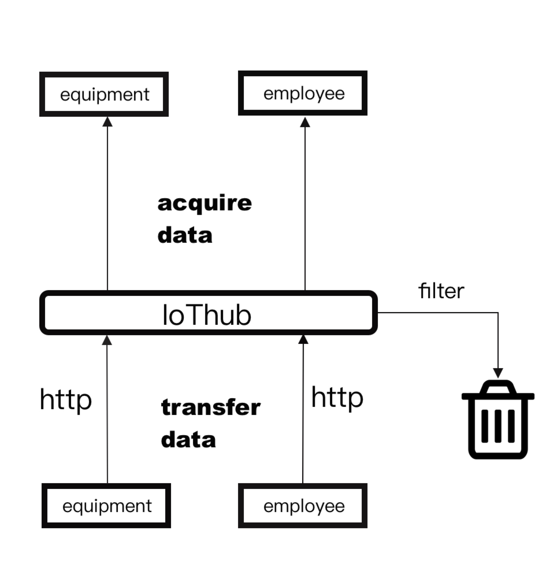

PLC→

/picture above ?? formatting issue ? /

Figure 1 - The process Of The System

* 1. Managent Performance

The system how to work:

1. The PLC will accept data and transfer data through specific HTTP to IoThub
2. IoThub will filter some unnecessary data
3. the data we needed will be passed to our web platform, mobile terminal facilities

Please explain PLC / is it http or https /like

1. System Analysis
   1. Overview

The IoTHub is a data driven platform with an information/data model following the W3C Web of Things recommendation. The data can be consumed using RESTful requests via HTTPS.

This system is using the API in order to provide a list of all devices (things). Selecting a device (thing) shows all its properties.

Please extend this part !

* 1. Functional Requirements

Ok !

Functions of User

* 1. profile
     + user’s fundamental information
  2. Logout and login
     + account
     + password
  3. Control devices
     + add devices
     + delete devices
     + Remove a property from a certain device
     + Check the state of the equipments

Functions of device

* 1. Sensor Values
  2. State & Configuration
  3. Actions & Commands

1. Pages Jump Logic & User Interface
   1. launch Page

Figure 2 - Launch Page

Wait a few seconds, the page will automatically jump to the login page.

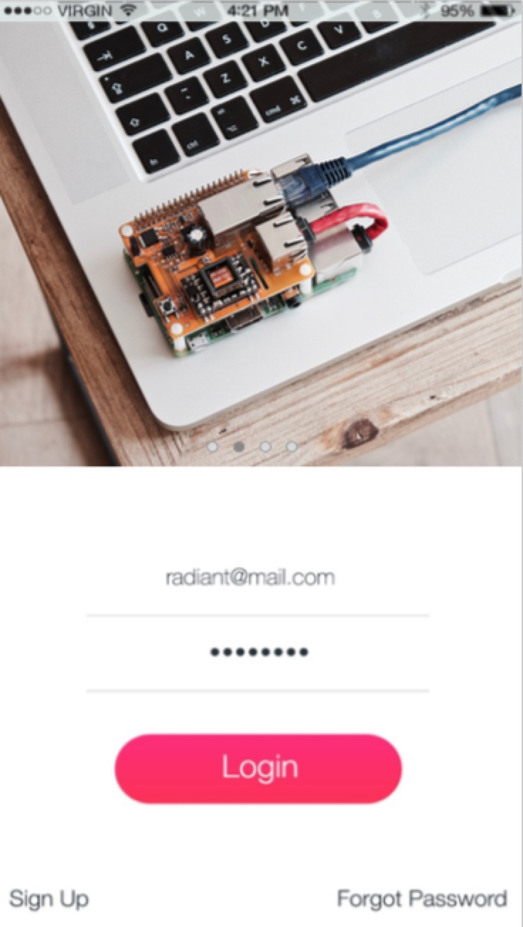

* 1. login Page

Figure 3 -Login Page

After enter the account password, click with the back-end connections, into the equipment after the validation.

Sign up: if you don’t have a account, click here, and get your account.

Forget Password: if you already have an account, but you forget your password, click here, find your password.

* 1. device Page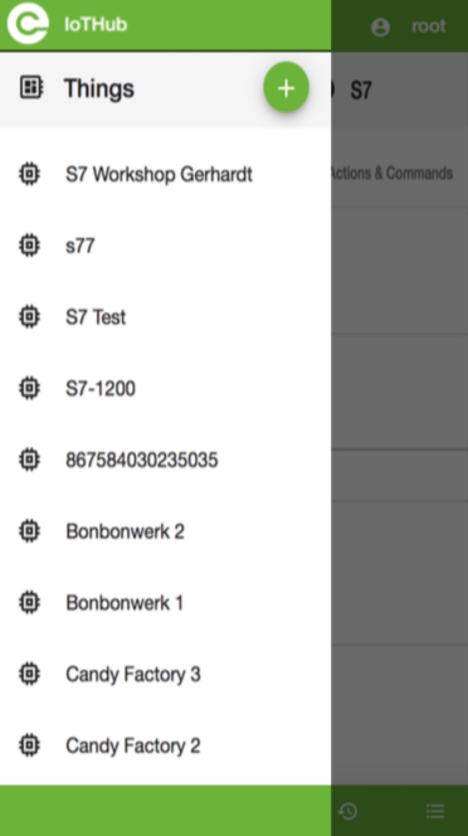

Figure 4 -Device Page

On this page, you can see all of the devices, choose one of the devices, you will get its Sensor Values, the state &Configuration and Actions & Commands.

You can also add devices, delete devices, add properties for device and delete properties.

* 1. API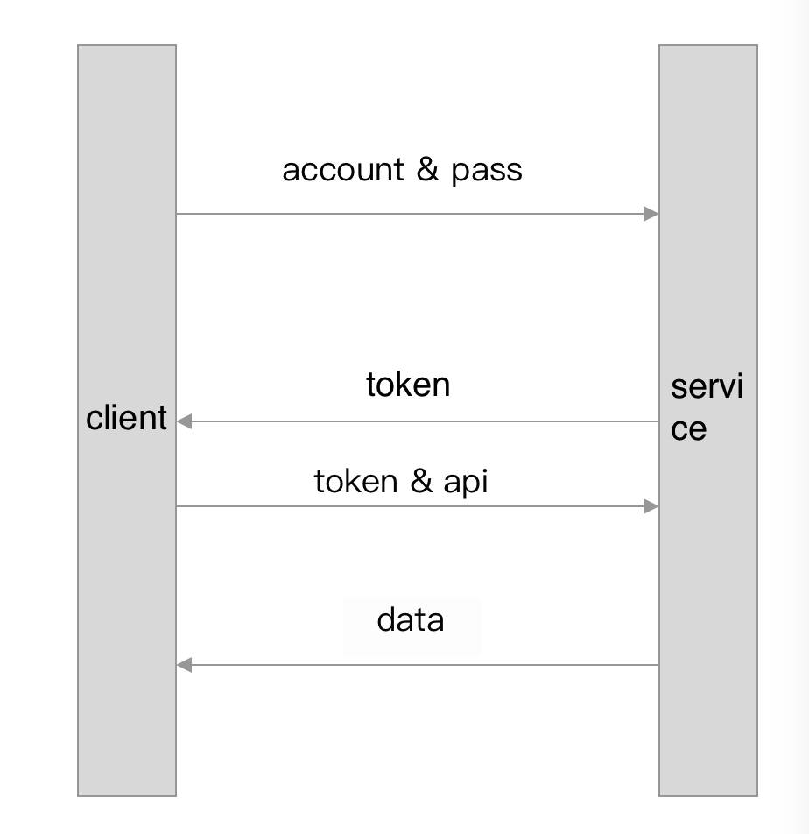

service

Figure 5 -API for process chart

Use Angular 7 and HttpClient to send HTTP requests or make API calls to RESTful endpoints of remote servers in order to fetch data.

client

How to get api: use JSON Server + JSON2TS + HttpClient + Service + DI Container store and get Web API.

* 1. Q&A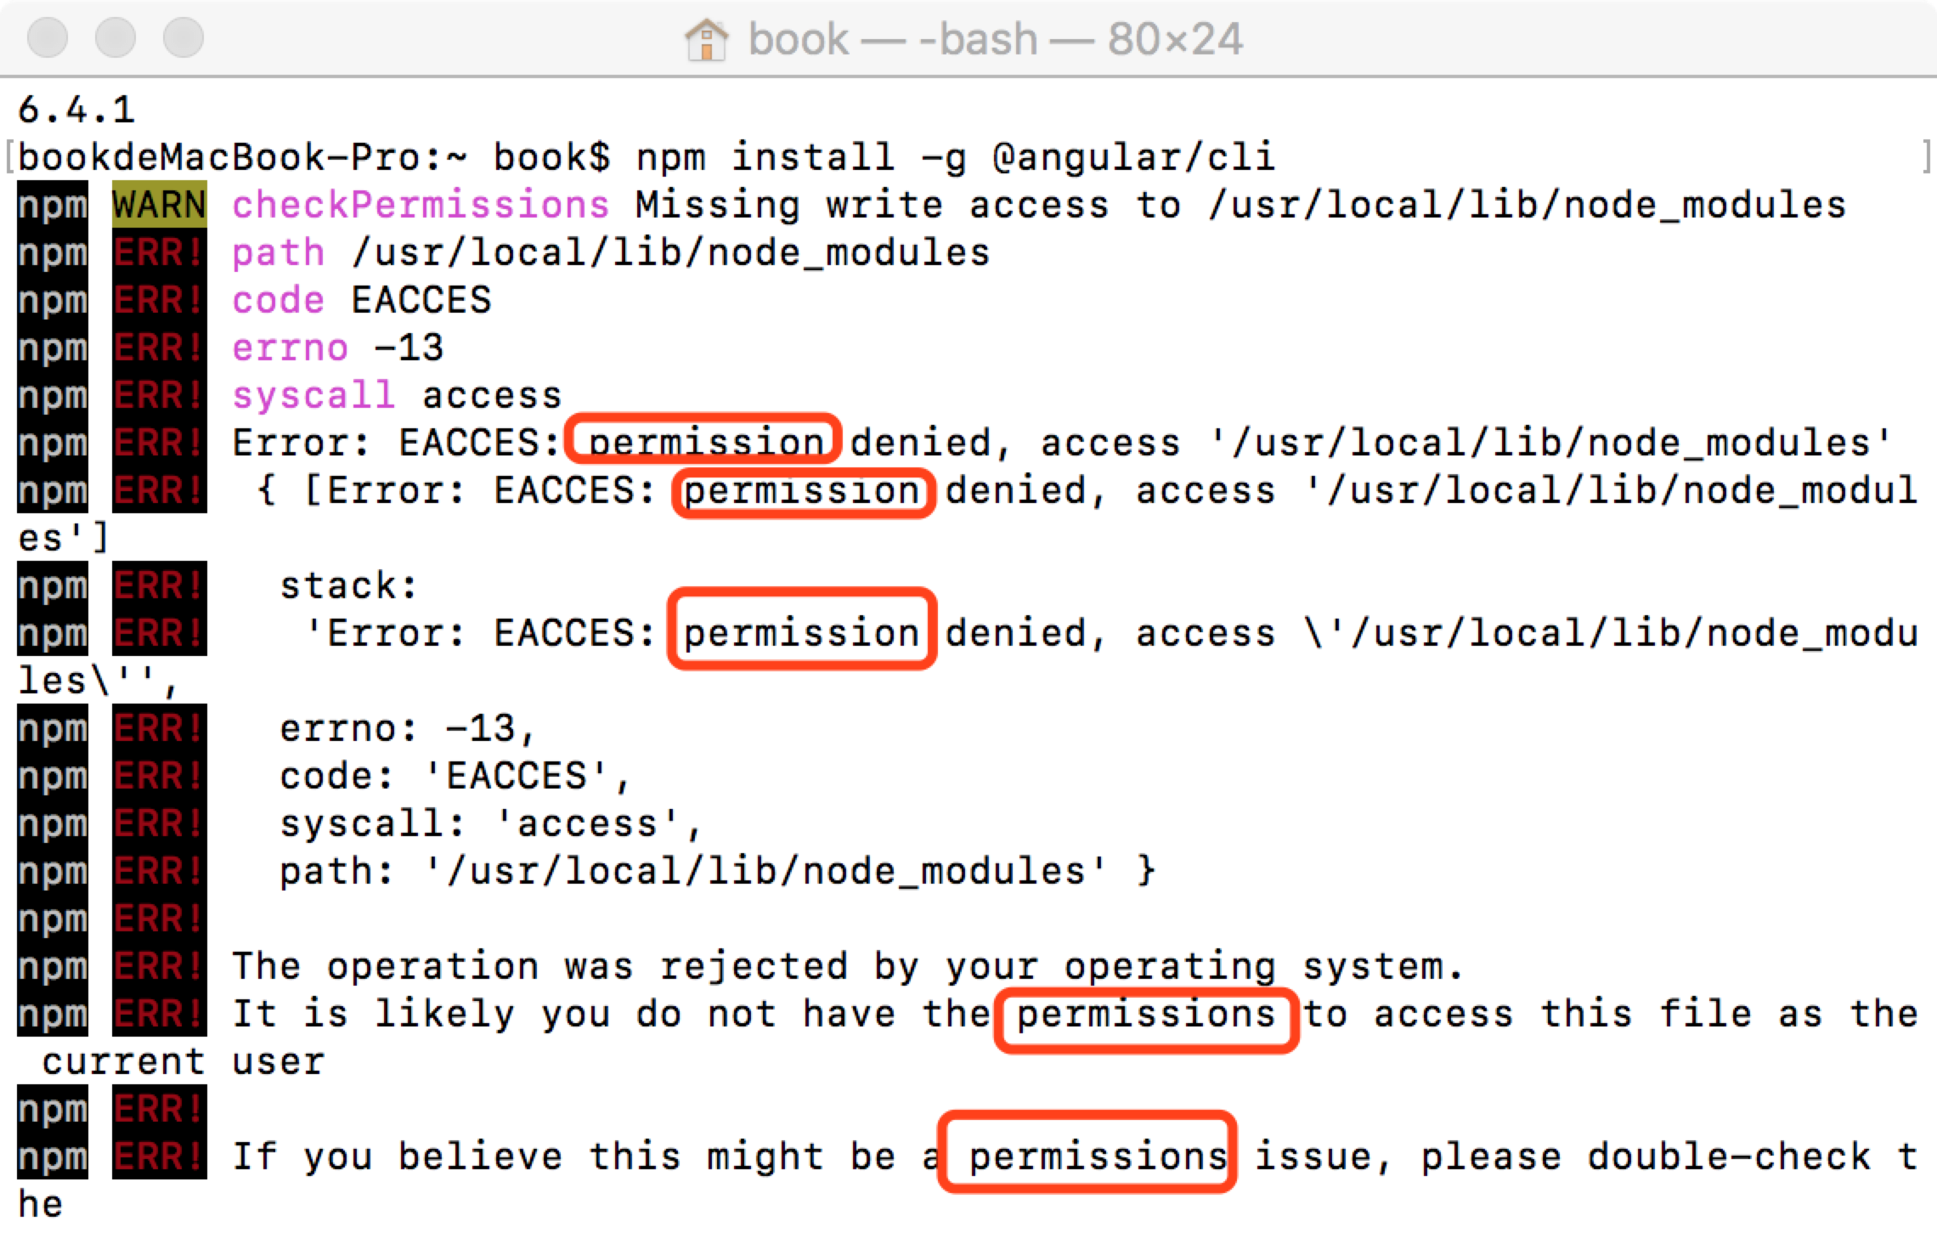

Q：

appear the word “impression”

S：

add “sudo”

Q:if ng build add “- -prod - -aot”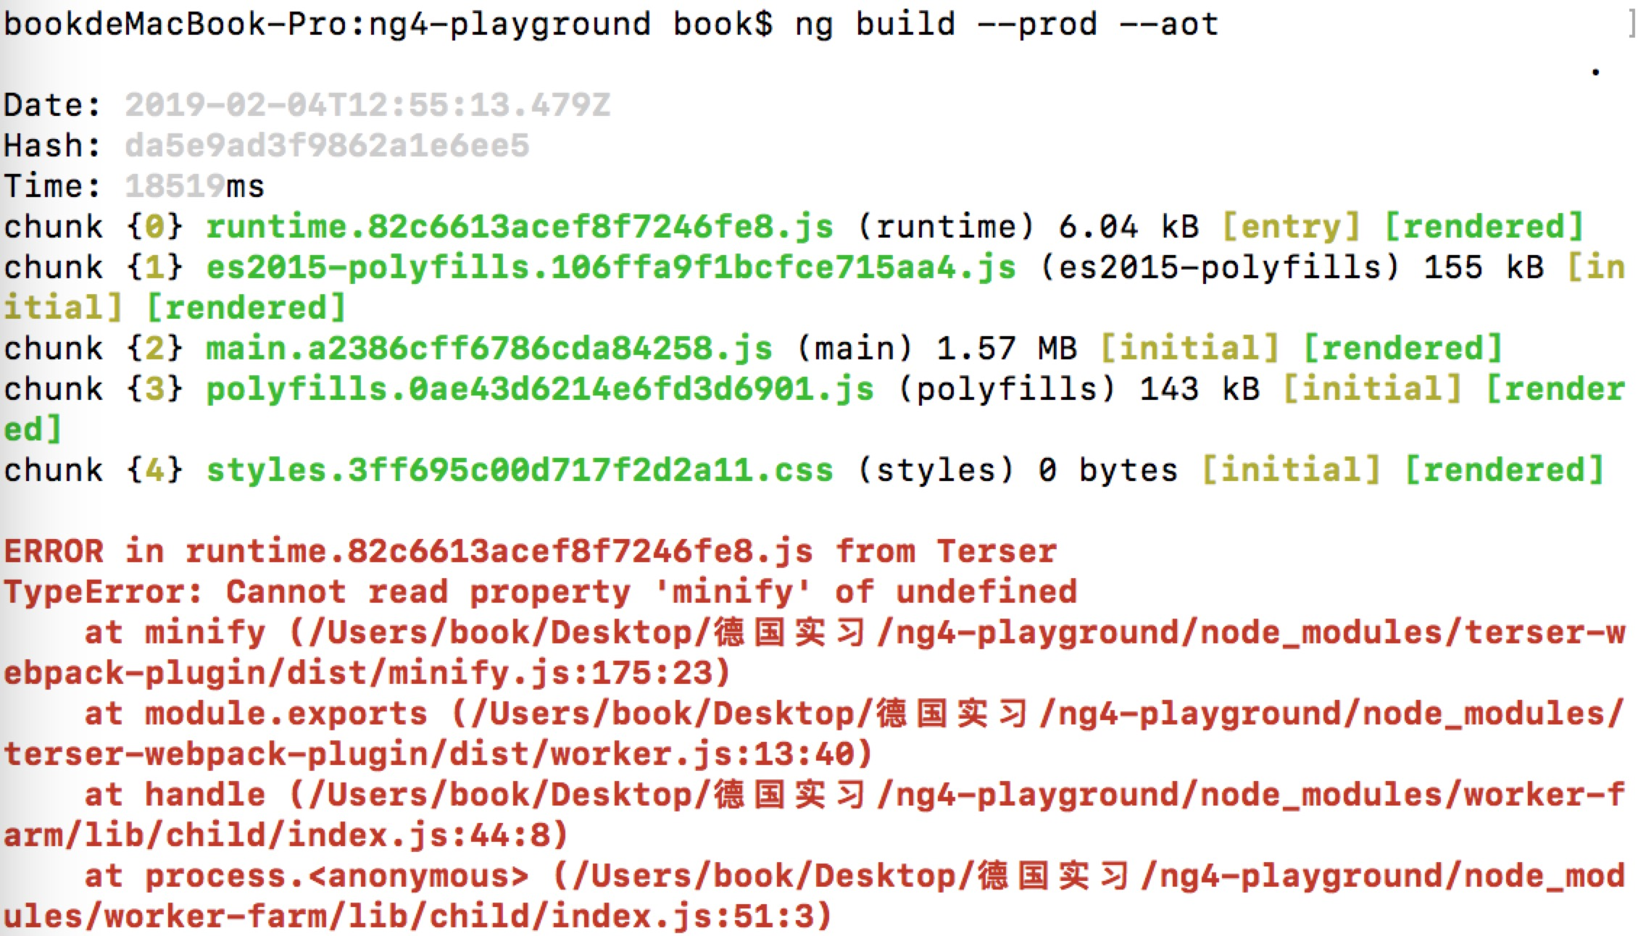, the result is it can’t operate

S: Terser version hasn't caught up with, because of the presents and I download the latest version of NPM, via NPM terser@3.16.1 - saveDev I this sentence, update to the latest terser college (https://stackoverflow.com/questions/54497980/cannot-build-prod-after-angular-5-to-7-update-terser-error)